Experiment 1: Threat Application
print("THREAT INTELLIGENCE APPLICATION CLASSIFIER")
print("-" * 45)

scenario = input("Enter a business scenario: ").lower()

if any(word in scenario for word in
["bank", "banking", "payment", "credit card", "financial"]):
result = "Banking Fraud Prevention"
reason = "Detect suspicious transactions and financial fraud."

elif any(word in scenario for word in
["hospital", "healthcare", "patient", "medical", "clinic"]):
result = "Healthcare Data Protection"
reason = "Protect patient records and detect healthcare threats."

elif any(word in scenario for word in
["e-commerce", "ecommerce", "online shopping",
"retail", "customer orders"]):
result = "E-commerce Fraud Prevention"
reason = "Detect fake orders, account abuse, and payment fraud."

elif any(word in scenario for word in
["school", "university", "college", "education"]):
result = "Education Sector Security"
reason = "Protect student records and institutional systems."

elif any(word in scenario for word in
["factory", "manufacturing", "industrial", "iot"]):
result = "Industrial and IoT Security"
reason = "Identify threats to connected devices and operations."

else:
result = "General Cybersecurity"
reason = "Identify threats, vulnerabilities, and suspicious activity."

print("\nRESULT")
print("Application Area:", result)
print("Reason:", reason)

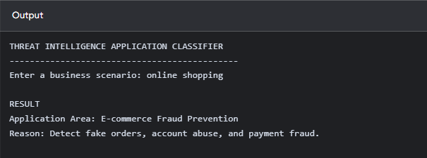

Experiment 2: Port Scanner

import socket

print("SIMPLE TCP PORT SCANNER")
print("-" * 35)

target = input("Enter target IP or hostname (default 127.0.0.1): ").strip()

if not target:
target = "127.0.0.1"

ports_input = input(
"Enter ports separated by commas (default 22,80,443,8080): "
).strip()

if ports_input:
try:
ports = sorted(set(int(p.strip()) for p in ports_input.split(",")))
if any(port < 1 or port > 65535 for port in ports):
raise ValueError("Ports must be between 1 and 65535.")
except ValueError as error:
print("Invalid port input:", error)
raise SystemExit
else:
ports = [22, 80, 443, 8080]

print("\nTarget:", target)
print("Scanning selected TCP ports...\n")

try:
for port in ports:
with socket.socket(socket.AF_INET, socket.SOCK_STREAM) as sock:
sock.settimeout(0.5)
result = sock.connect_ex((target, port))

if result == 0:
print(f"Port {port}: OPEN")
else:
print(f"Port {port}: CLOSED or FILTERED")

except socket.gaierror:
print("Error: Hostname could not be resolved.")
except OSError as error:
print("Network error:", error)

print("\nScan completed.")

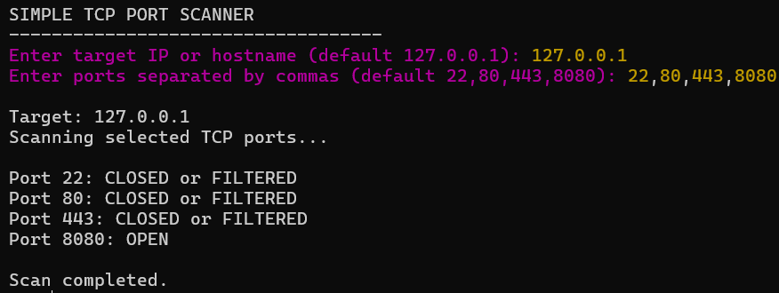

Experiment 3: Policy checker

print("SECURITY POLICY GOVERNANCE CHECKER")
print("-" * 42)

print("Paste your draft policy below.")
print("Type END on a separate line when finished.\n")

lines = []

while True:
line = input()
if line.strip().upper() == "END":
break
lines.append(line)

policy = " ".join(lines).lower()

requirements = {
"Scope": ["scope", "applies to", "coverage"],
"Roles and Responsibilities": [
"roles and responsibilities", "responsibilities", "accountabilities"
],
"Enforcement": ["enforcement", "disciplinary", "violations"],
"Review Cycle": ["review cycle", "reviewed annually",
"review every", "annual review"],
"Approval Authority": [
"approval authority", "approved by", "authorized by"
]
}

missing = []

print("\nASSESSMENT RESULTS")
print("-" * 42)

for element, keywords in requirements.items():
found = any(keyword in policy for keyword in keywords)

if found:
print(f"[PRESENT] {element}")
else:
print(f"[MISSING] {element}")
missing.append(element)

print("\nSUMMARY")

if not missing:
print("All five required elements were detected.")
else:
print("Missing elements:", len(missing))
for element in missing:
print("-", element)

print("\nAssessment completed.")

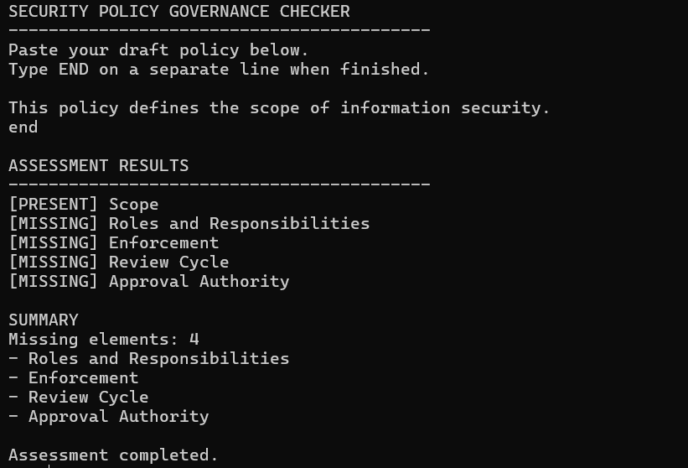

Experiment 4: VPN Demo

def encrypt(data, key):
data_bytes = data.encode("utf-8")
key_bytes = key.encode("utf-8")

encrypted = bytes(
byte ^ key_bytes[i % len(key_bytes)]
for i, byte in enumerate(data_bytes)
)

return encrypted

def decrypt(encrypted, key):
key_bytes = key.encode("utf-8")

decrypted = bytes(
byte ^ key_bytes[i % len(key_bytes)]
for i, byte in enumerate(encrypted)
)

return decrypted.decode("utf-8", errors="replace")

print("VPN CONFIDENTIALITY DEMONSTRATION")
print("-" * 42)

message = input("Enter a message to send: ")
key = input("Enter a shared key: ")

if not message or not key:
print("Error: Message and key must not be empty.")
raise SystemExit

ciphertext = encrypt(message, key)

print("\nOriginal message:", message)
print("Captured transit data (hex):", ciphertext.hex())
print("Without decryption, the data is not readable as plaintext.")

recovered = decrypt(ciphertext, key)
print("\nAfter decryption with the shared key:", recovered)

print("\nConfidentiality demonstration completed.")
print("WARNING: XOR is not secure VPN encryption.")

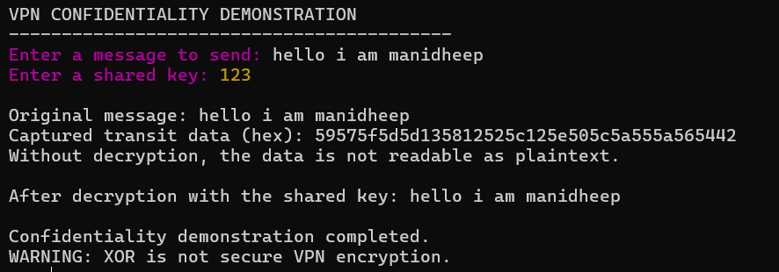

Experiment 5: Report Classifier

print("THREAT INTELLIGENCE REPORT CLASSIFIER")
print("-" * 45)

description = input("Enter report description: ").lower()
audience = input("Enter intended audience: ").lower()

strategic_words = [
"business risk", "executive", "long-term", "geopolitical",
"industry trends", "business impact", "senior management",
"investment decision"
]

tactical_words = [
"attack techniques", "tactics", "procedures", "ttp",
"mitre", "attacker behavior", "attack patterns",
"threat actor methods"
]

operational_words = [
"incident", "active attack", "ip address", "ioc",
"indicator of compromise", "malware hash", "alert",
"malicious domain", "investigation"
]

strategic_audience = [
"executive", "management", "board", "director", "business leader"
]

tactical_audience = [
"security team", "threat hunter", "red team", "blue team"
]

operational_audience = [
"soc analyst", "incident responder", "incident response",
"forensic analyst", "security analyst"
]

def count_matches(text, keywords):
return sum(1 for word in keywords if word in text)

scores = {
"Strategic": (
count_matches(description, strategic_words)
+ count_matches(audience, strategic_audience)
),
"Tactical": (
count_matches(description, tactical_words)
+ count_matches(audience, tactical_audience)
),
"Operational": (
count_matches(description, operational_words)
+ count_matches(audience, operational_audience)
)
}

print("\nCLASSIFICATION RESULTS")
for category, score in scores.items():
print(f"{category}: {score} matching indicators")

highest = max(scores.values())
winners = [name for name, score in scores.items() if score == highest]

if highest == 0:
result = "Unclassified"
elif len(winners) > 1:
result = "Ambiguous: " + ", ".join(winners)
else:
result = winners[0]

print("\nReport classification:", result)
print("Note: This is a keyword-based educational classifier.")

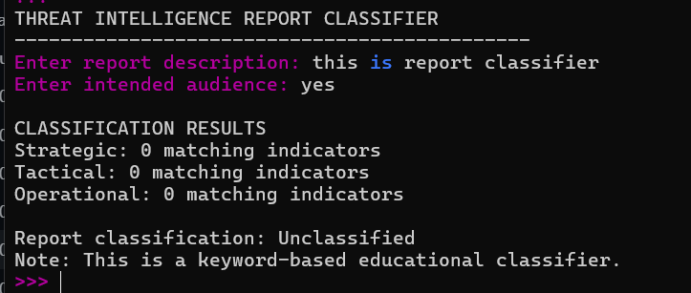

Experiment 6: Phishing Detector

from urllib.parse import urlparse
import ipaddress

def detect_phishing(url):
score = 0
reasons = []

parsed = urlparse(url if "://" in url else "http://" + url)
domain = parsed.hostname or ""

keywords = ["login", "verify", "update", "password",
"banking", "secure", "account"]

if any(word in url.lower() for word in keywords):
score += 1
reasons.append("Suspicious keyword found")

try:
ipaddress.ip_address(domain)
score += 1
reasons.append("IP address used as domain")
except ValueError:
pass

if len(domain.split(".")) > 4:
score += 1
reasons.append("Excessive subdomains")

if parsed.scheme == "http":
score += 1
reasons.append("Uses HTTP instead of HTTPS")

if score >= 2:
print("Warning: Suspicious URL detected!")
else:
print("No major phishing indicators detected.")

print("Risk score:", score)
for reason in reasons:
print("-", reason)

url = input("Enter a URL: ")
detect_phishing(url)

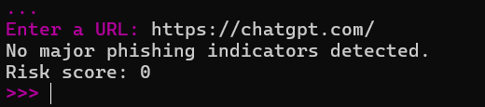

Experiment 7: ELF Stack

import re
from collections import Counter

# Raw log lines
logs = [
"192.168.1.10 GET /home 200",
"192.168.1.20 POST /login 401",
"192.168.1.10 GET /home 200",
"192.168.1.30 POST /login 403"
]

# Logstash-style parsing
def parse_log(line):
pattern = r"(\S+)\s+(\S+)\s+(\S+)\s+(\d+)"
match = re.match(pattern, line)

if match:
ip, method, path, status = match.groups()
return {
"ip": ip,
"method": method,
"path": path,
"status": int(status)
}

return None

# Elasticsearch-style indexing
index = []

for log in logs:
event = parse_log(log)
if event:
index.append(event)

print("Structured Events:")
for event in index:
print(event)

# Kibana-style aggregation
status_counts = Counter(
event["status"] for event in index
)

print("\nStatus Code Summary:")
for status, count in sorted(status_counts.items()):
print(status, ":", count)

print("\nTotal logs indexed:", len(index))

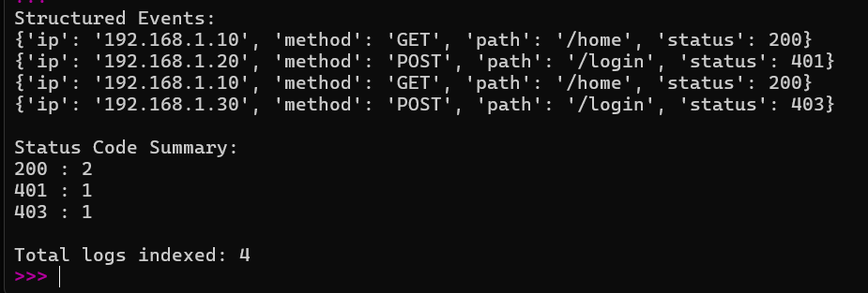

Experiment 8: Network Segmentation

# Define network segments
segments = {
"Guest": 1,
"Employee": 2,
"Sensitive": 3
}

# Access policy
allowed_access = {
"Guest": ["Guest"],
"Employee": ["Employee", "Guest"],
"Sensitive": ["Sensitive", "Employee"]
}

def check_access(source, destination):
print(f"{source} -> {destination}")

if destination in allowed_access[source]:
print("Access ALLOWED\n")
else:
print("Access BLOCKED by segmentation policy\n")

# Simulate network traffic
check_access("Guest", "Guest")
check_access("Guest", "Sensitive")
check_access("Employee", "Sensitive")
check_access("Sensitive", "Employee")

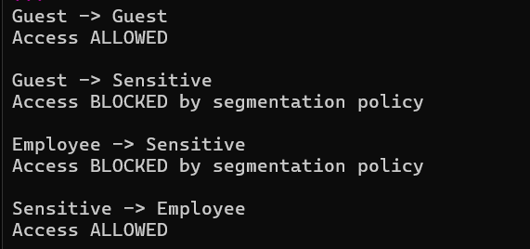

Experiment 9: Threat Lifecycle

def identify_stage(activity):
activity = activity.lower()

stages = {
"Direction": ["requirement", "priority", "objective", "planning"],
"Collection": ["collect", "gather", "capture", "obtain"],
"Processing": ["clean", "filter", "organize", "normalize"],
"Analysis": ["analyze", "investigate", "correlate", "interpret"],
"Dissemination": ["share", "report", "distribute", "communicate"],
"Feedback": ["feedback", "review", "improve", "suggest"]
}

for stage, keywords in stages.items():
if any(word in activity for word in keywords):
return stage

return "Stage not identified"

activity = input("Enter the intelligence team activity: ")
stage = identify_stage(activity)

print("Threat Intelligence Lifecycle Stage:", stage)

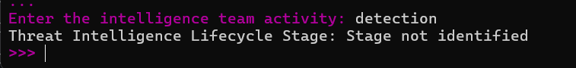

Experiment 10: State full fire work

# Track established outbound connections
connections = set()

def outbound(source, destination, port):
connection = (source, destination, port)
connections.add(connection)

print("Outbound connection ALLOWED")
print("Connection recorded:", connection)

def inbound(source, destination, port):
# Check whether this is return traffic
connection = (destination, source, port)

if connection in connections:
print("Inbound return traffic ALLOWED")
else:
print("Inbound traffic BLOCKED")

# Simulate network traffic
outbound("Client", "WebServer", 443)

inbound("WebServer", "Client", 443)
inbound("UnknownHost", "Client", 22)

